Gizzle Bautista ( S0261553 ) COIT20245 – Introduction to Programming

1. Test Scenario: User input with name (validation includes characters and space between first and last name) and amount validation

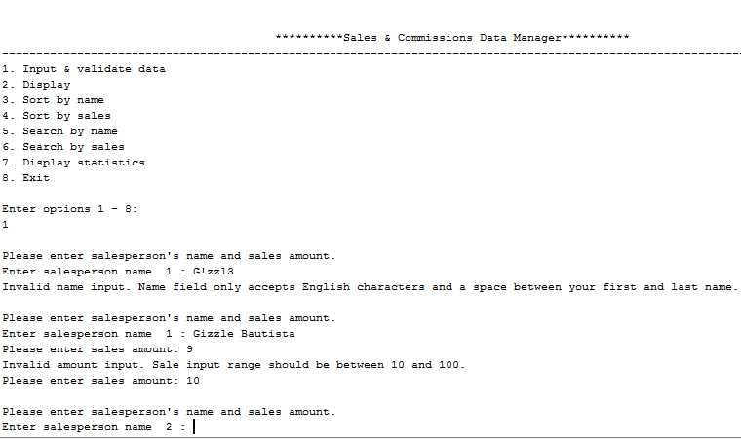

1. Test Scenario: First run validation for input requirement

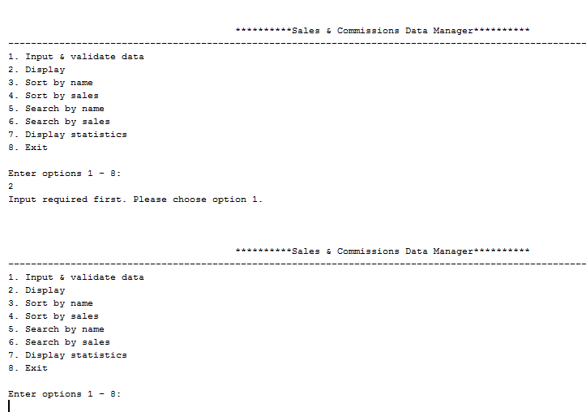

1. Test Scenario: Displaying unsorted data

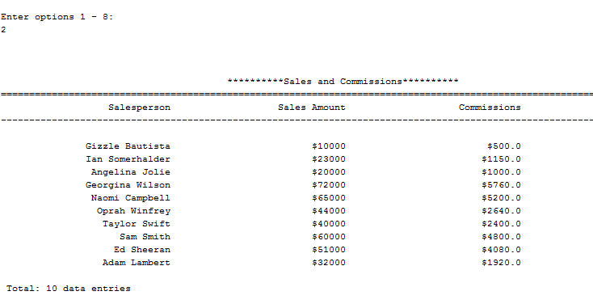

1. Test Scenario: Displaying sorted name

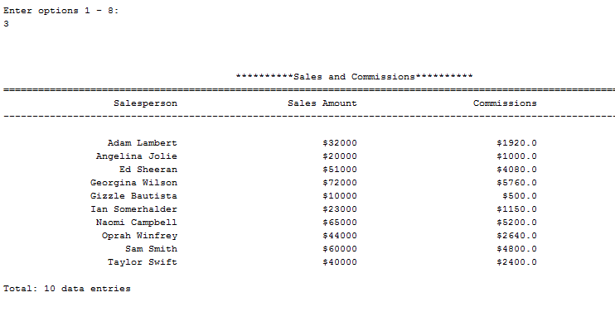

1. Test Scenario: Displaying sorted sales amount

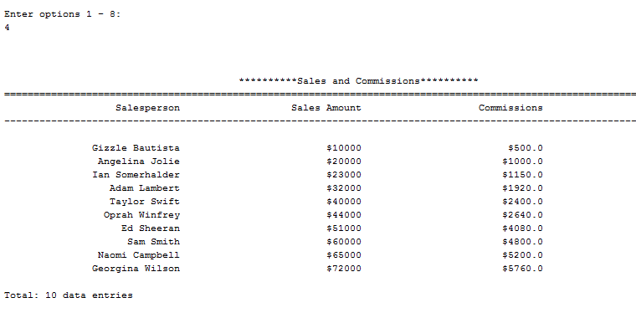

1. Test Scenario: Display searched name and sales amount

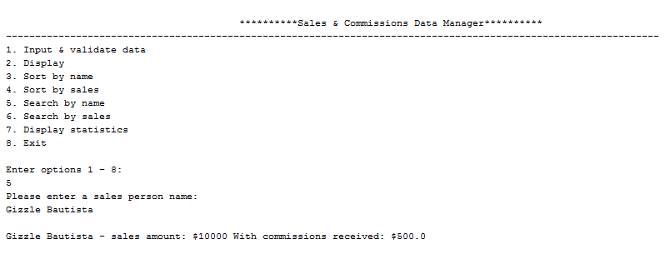

1. Test Scenario: Display searched sales amount

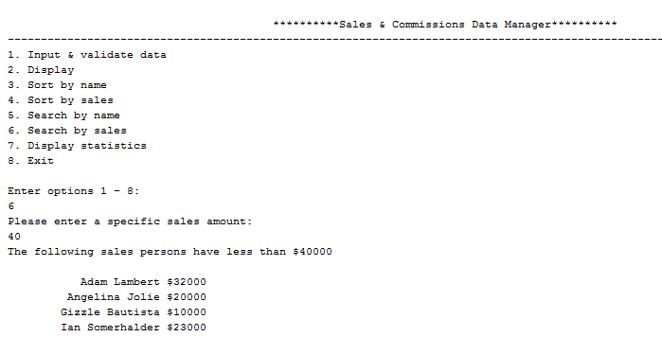

1. Test Scenario: Display statistics and exit

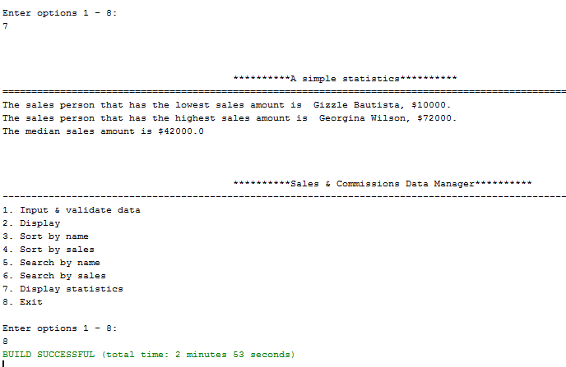

**II. UML**

